d
Detection and Classification of Financial Scams in SMS or Chat Messages

Prepared By-
Al Rafi Ahmed
Gazi Faizul Islam

A Thesis in the Partial Fulfillment of the Requirements
for the Award of Bachelor of Computer Science and Engineering (BCSE)

Department of Computer Science and Engineering
College of Engineering and Technology
IUBAT—International University of Business Agriculture and Technology
Fall 2025

Detection and Classification of Financial Scams in SMS or Chat Messages
Al Rafi Ahmed (22203178) Gazi Faizul Islam (22203175)

A Thesis in the Partial Fulfillment of the Requirements for the Award of Bachelor of Computer Science and Engineering (BCSE)
The thesis has been examined and approved,

_____________________________
Prof. Dr. Utpal Kanti Das
Chairman

_____________________________
Md. Rashedul Islam
Co-supervisor, Coordinator and Assistant Professor

_____________________________
Tanzina Tasnim Bithi
Supervisor & Assistant Professor

Department of Computer Science and Engineering
College of Engineering and Technology
IUBAT—International University of Business Agriculture and Technology
Fall 2025

Letter of Transmittal
5 October 2025
The Chair
Thesis Defense Committee
Department of Computer Science and Engineering
IUBAT—International University of Business Agriculture and Technology
4 Embankment Drive Road, Sector 10, Uttara Model Town
Dhaka 1230, Bangladesh.
Subject: Letter of Transmittal.
Dear Sir,
We are pleased to submit our thesis, titled “Detection and Classification of Financial Scams in SMS or Chat Messages.” It was a great opportunity for us to work on this study to make our theoretical knowledge more realistic and we gained a lot of exposure about doing deep research of ML. We now look forward to your kind commentary on this performance report. Our work aims to enhance accuracy and assist healthcare professionals in early diagnosis.
We sincerely appreciate the guidance and support of our thesis supervisor, faculty members, and peers. Their insights have been invaluable. We hope this research contributes meaningfully to the collaboration of technology and medical field and kindly request your evaluation and feedback.

Yours sincerely,
_____________ _____________
Al Rafi Ahmed Gazi Faizul Islam
22203178 22203175

Student’s Declaration
We, Al Rafi Ahmed bearing ID: 22203178 and Gazi Faizul Islam bearing ID: 22203175, are students of the BCSE-Bachelor of Computer Science and Engineering program, under the College of Engineering and Technology (CEAT) of the International University of Business Agriculture and Technology (IUBAT) announcing, this report entitled “Detection and Classification of Financial Scams in SMS or Chat Messages” has been prepared for the completion of the CSC 488 Thesis course, which is part of the Bachelor of Computer Science and engineering degree.
The work presented in this thesis paper titled, “Detection and Classification of Financial Scams in SMS or Chat Messages” is our original work and has not been presented elsewhere for assessment or award of any other degree or any other publication and additional resources have been properly acknowledged and referred.

_____________ _____________
Al Rafi Ahmed Gazi Faizul Islam
22203178 22203175

Supervisor’s Certification
This is to certify that the thesis report on “Detection and Classification of Financial Scams in SMS or Chat Messages” has been carried out by Al Rafi Ahmed (22203178) and Gazi Faizul Islam (22203175), the students of Department of Computer Science and Engineering, IUBAT-International University of Business Agriculture and Technology. The report has been prepared under my guidance and is a record of work carried out successfully. To the best of my knowledge and as per their declaration, no parts of this report has been submitted anywhere for any degree, diploma or certificate.

You are now allowed to submit a report. I wish them every success in their future endeavors.

Tanzina Tasnim Bithi
Supervisor and Assistant Professor

Department of Computer Science and Engineering
IUBAT–International University of Business Agriculture and Technology

Abstract

Financial scams transmitted through SMS and chat messages have become a significant and rapidly growing threat to digital communication, frequently resulting in financial loss and the exposure of sensitive personal information. As mobile messaging platforms continue to expand, fraudsters increasingly exploit these channels by crafting deceptive messages that often imitate legitimate institutions and use persuasive language to manipulate users into sharing confidential data such as passwords, verification codes, and banking credentials. The continuously rising volume of text-based communication makes manual detection both inefficient and unreliable, as human judgment is often inconsistent when faced with evolving fraud patterns. These challenges highlight the urgent need for an automated and intelligent detection system capable of identifying fraudulent content with accuracy and speed. This thesis presents a machine learning-based framework for the detection and classification of financial scam messages using a custom-built dataset derived from real-world communication patterns. The dataset incorporates diverse linguistic structures, including informal expressions and code-mixed text, allowing the model to better adapt to complex and dynamic scam strategies. Several preprocessing techniques, such as text cleaning, normalization, tokenization, and feature extraction, were applied to transform unstructured messages into meaningful representations that enhance classification performance. Multiple machine learning models were trained and evaluated to ensure reliable detection while maintaining computational efficiency suitable for large-scale applications. Experimental results demonstrate that the proposed model effectively differentiates fraudulent messages from legitimate communication, achieving strong overall performance across standard evaluation metrics. The findings emphasize the importance of domain-specific datasets in developing robust fraud detection systems and highlight the potential of intelligent text classification techniques in strengthening digital security. This research establishes a solid foundation for future advancements, where more sophisticated algorithms, expanded datasets, and real-time deployment strategies can further improve detection capability and support safer digital communication environments.

Acknowledgments
First, we would like to thank the Department of Computer Science and Engineering of International University of Business Agriculture and Technology (IUBAT) in terms of having a favorable academic environment and the resources required to conduct this research work. The academic excellence that was enshrined in the department helped a great deal in the successful completion of this thesis. We would also like to express our highest regards and gratefulness to our supervisor, Tanzina Tasnim Bithi, Assistant Professor, Department of Computer Science and Engineering, who had invaluable guidance, constant encouragement, as well as constructive feedback, during the whole research process. Her patience, suggestions and academic contribution were instrumental in determining the quality and orientation of this work. We do not hesitate to appreciate our fellow students and friends who have shown moral support, fruitful discussions, and encouragement throughout the academic journey thus making the research process fruitful and fulfilling. Last but not the least we would also like to give our genuine gratitude to our familial love, patience and unwavering support. Their support and tolerance were key to our inspiration and achievement in achieving this thesis.

Table of Contents
Letter of Transmittal ............................................................................................................... iii
Student’s Declaration .............................................................................................................. iv
Supervisor’s Certification ........................................................................................................ v
Abstract ................................................................................................................................... vi
Acknowledgments ….............................................................................................................viii
List of Figures .....................................................................................................................….xi
List of Tables ..........................................................................................................................xii
Chapter 1. Introduction ........................................................................................................ 1
1.1 Introduction .................................................................................................................... 1
1.2 Problem Statement.......................................................................................................... 2
1.3 Objectives of the study ................................................................................................... 3
1.3.1 Development of an Intelligent Scam Detection Model........................................ 3
1.3.2 Construction and Utilization of a Realistic Custom Dataset.................................4
1.3.3 Advanced Text Preprocessing and Feature Engineering........................................4
1.3.4 Comparative Analysis of Machine Learning Models...........................................4
1.3.5 Performance Evaluation Using Standard Metrics............... ...................................4
1.3.6 Model Optimization for Efficiency and Scalability................................................5
1.4 Contributions ................................................................................................................. 5
Chapter 2. Literature Review ............................................................................................... 7
2.1 Overview ........................................................................................................................ 7
2.2 SMS Spam Detection Using Machine Learning............................................................. 7
2.3 Financial Scam Message Detection................................................................................ 7
2.4 Summary and Research Gap .......................................................................................... 9
Chapter 3. Research Methodology ....................................................................................... 9
3.1 Research Approach......................................................................................................... 9
3.2 Research Method .................................................................................................... 10
3.3 Data Description....................................................................................................... 11
3.4 Data Collection......................................................................................................... 13
3.5 Data Preprocessing................................................................................................... 15
3.6 Feature Extraction..................................................................................................... 16
3.7 Model Development..................................................................................................... 18
3.8 Model Evaluation………...……………………………………………………………22
3.9 Implementation Environment........................................................................................23
3.10 Chapter Summary ...................................................................................................... 25
Chapter 4. Results and Discussion ....................................................................................26 4.1 Dataset Analysis.............................................................................................................. 26
4.2 Experimental Setup..................................................................................................... 34
4.3 Performance Comparison of Machine Learning Models........................................... 35
4.4 Confusion Matrix Analysis........................................................................................ 37
4.5 ROC Curve Analysis.................................................................................................. 39
4.6 Discussion of Results................................................................................................. 41
4.7 Error Analysis............................................................................................................ 42
4.7.1 Analysis of False Positives................................................................................44
4.7.2 Analysis of False Negatives..............................................................................44
4.8 Chapter Summary ...................................................................................................... 44
Chapter 5. Conclusion ....................................................................................................... 46
5.1 Conclusion ................................................................................................................. 46
5.2 Limitations ................................................................................................................. 46
5.3 Future Work ............................................................................................................... 47
5.4 Ethical Considerations................................................................................................ 47
References ........................................................................................................................... 31
Plagiarism Report .............................................................................................................. 32

List of Figures
Figure 3.1 Data Collection Process......................................................................................... 14
Figure 3.2 – Text Data Preprocessing Workflow.................................................................... 16
Figure 3.3 – TF-IDF Feature Extraction Process.................................................................... 17
Figure 3.4 – Machine Learning Model Development Process............................................... 21
Figure 3.5 Overall Research Workflow of the Proposed Financial Scam Detection System..................................................................................... ............................................... 25
Figure 4.1 – Class Distribution of Scam and Ham Messages ................................................ 27
Figure 4.2 Correlation Matrix of Textual Features................................................................. 31
Figure 4.3 Most Frequent Words in Scam Messages............................................................. 32
Figure 4.4 Most Frequent Words in Ham Messages............................................................. 33
Figure 4.5 Machine Learning Workflow for Financial Scam Detection.. .............................34
Figure 4.6 Confusion Matrix of the Support Vector Machine (SVM) Model…....................38
Figure 4.7 ROC Curve of the Support Vector Machine (SVM) Model…..............................40

List of Tables
Table 2.1 Methodological Comparison of Existing Studies and Proposed Work................. 8
Table 3.1 Dataset Distribution with Train-Test Split.......................................................... 13
Table 3.2 Machine Learning Models Used in This Study................................................... 21
Table 3.3 Evaluation Metrics Used in This Study .............................................................. 23
Table 3.4 Implementation Tools and Technologies............................................................ 24
Table 4.1 Average Word Count in Scam and Ham Messages............................................. 28
Table 4.2 Average Message Length in Scam and Ham SMS.............................................. 28
Table 4.3 Average Number of Sentences in Scam and Ham Messages.............................. 29
Table 4.4 Performance Comparison of Machine Learning Models…………………..…...36

Chapter 1. Introduction

1.1 Introduction
Financial scams transmitted through SMS and chat messages have become one of the most critical challenges in modern digital communication. As mobile devices and online messaging platforms continue to expand globally, fraudsters increasingly exploit these channels to deceive users into revealing sensitive information or transferring money. These scams not only cause substantial financial losses but also erode public trust in digital services. Fraudulent messages often mimic legitimate institutions, use persuasive language, and evolve rapidly, making them difficult for individuals to recognize. Consequently, the growing scale and sophistication of text-based financial fraud presents serious technological and security concerns for individuals and organizations alike.
Early and accurate identification of scam messages is essential for preventing financial damage and enhancing user safety. However, manual detection is inefficient due to the massive volume of daily messages and the subtle linguistic patterns used by scammers. Human judgment alone is often inconsistent, as fraudulent texts may closely resemble genuine communication. This challenge highlights the urgent need for automated, intelligent systems capable of detecting deceptive content with high reliability and speed. Such systems can support digital security by filtering suspicious messages before they reach potential victims.
Recent advancements in machine learning and natural language processing have created new opportunities for automated text classification. These techniques enable systems to analyze language patterns, extract meaningful features, and categorize messages with impressive accuracy. Despite these developments, several challenges remain. Many existing models struggle to balance detection performance with computational efficiency, while others rely heavily on generic datasets that fail to capture the complexity of real-world communication. Variations in writing styles, informal language, and code-mixed text further complicate the classification process. This trade-off between accuracy, adaptability, and efficiency continues to be a central challenge in developing robust financial scam detection systems.
To address these limitations, this research focuses on designing an effective machine learning-based framework trained on a custom dataset that reflects authentic messaging patterns. By applying structured preprocessing techniques and evaluating multiple classification approaches, the study aims to develop a reliable model capable of distinguishing fraudulent messages from legitimate ones. The proposed approach seeks to enhance detection capability while maintaining practical efficiency, ultimately contributing to safer digital communication environments and providing a strong foundation for future advancements in automated fraud prevention.
1.2 Problem Statement
The rapid expansion of digital communication through SMS and chat platforms has created new avenues for financial fraud, allowing scammers to target individuals with deceptive messages designed to extract sensitive information or manipulate users into transferring money. These fraudulent messages often imitate legitimate sources and employ persuasive language techniques, making them difficult for users to identify. As messaging services continue to grow, the volume and sophistication of scam communications have increased significantly, posing serious risks to both individuals and digital security.
Existing approaches to detecting fraudulent messages primarily rely on manual review or traditional filtering techniques, which are often inefficient, time-consuming, and unable to adapt to evolve scam patterns. Rule-based systems, while useful in controlled scenarios, frequently fail to recognize newly emerging fraud strategies and complex linguistic variations present in real-world communication. Consequently, many scam messages bypass detection mechanisms, increasing the likelihood of financial loss and privacy breaches.
Although machine learning has shown promise in automated text classification, developing a reliable detection system remains challenging due to the unstructured nature of textual data, variations in writing styles, and the presence of informal language. Furthermore, models trained on generalized datasets may struggle to accurately capture the characteristics of real communication patterns, limiting their effectiveness in practical applications. These challenges emphasize the need for a robust and intelligent framework capable of accurately distinguishing fraudulent messages from legitimate ones while maintaining computational efficiency.
Therefore, the primary problem addressed in this research is the development of an effective machine learning-based system for the detection and classification of financial scam messages. The goal is to design a model that can analyze textual features, adapt to diverse language patterns, and provide accurate classification to support safer digital communication and reduce the risks associated with financial fraud.
1.3 Objectives of the Study
The primary objective of this research is to design and develop an intelligent, efficient, and scalable machine learning-based framework for the detection and classification of financial scam messages transmitted through SMS and chat platforms. With the rapid growth of digital communication, fraudulent messages have become increasingly sophisticated, making traditional detection approaches insufficient. This study therefore focuses on building a robust automated system capable of analyzing textual data, identifying deceptive patterns, and accurately distinguishing fraudulent messages from legitimate communication. The research emphasizes improving detection reliability, strengthening text analysis capabilities, and supporting the development of smarter security mechanisms for modern communication environments.
To accomplish this goal, the following specific objectives have been established:
1.3.1 Development of an Intelligent Scam Detection Model
One of the central objectives of this study is to develop an intelligent detection model capable of automatically identifying financial scam messages with a high degree of accuracy. The model will utilize machine learning techniques to recognize linguistic patterns, suspicious keywords, and contextual indicators commonly associated with fraudulent communication. By training the model on structured and carefully prepared data, the research aims to reduce reliance on manual message screening while ensuring consistent and unbiased detection. The system is expected to enhance early identification of scams, thereby minimizing potential financial risks and improving overall digital safety.
1.3.2 Construction and Utilization of a Realistic Custom Dataset
A critical objective of this research is the creation and effective utilization of a custom dataset that reflects authentic communication patterns. Since fraudulent messages often vary in structure, tone, and writing style, relying solely on generalized datasets may limit detection performance. Therefore, this study prioritizes the use of realistic textual data to ensure that the trained models can adapt to practical scenarios. The dataset will serve as the foundation for training, validation, and testing processes, enabling the development of a detection system that is both reliable and applicable to real-world environments.
1.3.3 Advanced Text Preprocessing and Feature Engineering
Financial scam messages typically exist in unstructured textual form, requiring systematic preprocessing before meaningful analysis can be performed. This research aims to implement comprehensive preprocessing techniques such as text cleaning, normalization, removal of irrelevant characters, tokenization, and feature extraction. Effective feature engineering will transform raw messages into structured representations that improve the learning capability of machine learning models. By enhancing data quality and reducing noise, this objective seeks to significantly improve classification accuracy while supporting efficient model training.
1.3.4 Comparative Analysis of Machine Learning Models
Another major objective of this study is to train and evaluate multiple machine learning algorithms to determine the most effective approach for detecting fraudulent messages. Different models often exhibit varying strengths in handling textual data, making comparative analysis essential for selecting the optimal solution. This research will systematically assess model performance to identify the approach that delivers the best balance between detection capability and computational efficiency. Such evaluation ensures that the proposed framework is not only accurate but also practical for large-scale implementation.
1.3.5 Performance Evaluation Using Standard Metrics
To ensure the reliability of the proposed system, this study aims to conduct a comprehensive performance evaluation using widely accepted metrics such as accuracy, precision, recall, and F1-score. These metrics provide a multidimensional understanding of the model’s effectiveness, particularly in minimizing false positives and false negatives. Through structured experimentation and validation, the research seeks to confirm that the developed system maintains consistent performance across different testing scenarios.
1.3.6 Model Optimization for Efficiency and Scalability
Beyond detection accuracy, this research also focuses on optimizing the developed models to ensure computational efficiency. An effective scam detection system must be capable of processing large volumes of messages without significant delays. Therefore, this objective emphasizes achieving a balance between predictive performance and resource utilization, enabling the framework to remain scalable and adaptable for real-world deployment.
1.4 Contributions
This research makes several significant contributions toward enhancing the automated detection of financial scam messages in digital communication environments. It proposes a machine learning-based detection framework capable of intelligently identifying and classifying fraudulent messages from SMS and chat platforms by analyzing textual patterns with improved reliability. A custom dataset was developed and utilized to ensure that the models learn from realistic communication styles rather than relying solely on generalized data, thereby strengthening practical applicability. The study further implements comprehensive text preprocessing techniques—including cleaning, normalization, tokenization, and feature extraction—to transform unstructured text into meaningful numerical representations that enhance model learning and classification accuracy. Multiple machine learning algorithms were trained and comparatively evaluated to determine the most effective approach, ensuring an optimal balance between predictive performance and computational efficiency. The framework’s effectiveness was validated using standard evaluation metrics such as accuracy, precision, recall, and F1-score, confirming the robustness and consistency of the system. Ultimately, by facilitating the early detection of deceptive messages, this research contributes to improving digital security and supports broader efforts aimed at reducing financial risks associated with scam activities.

Chapter 2. Literature Review
2.1 Overview
The proliferation of SMS and chat-based communications has led to an increase in unsolicited and fraudulent messages. Machine learning (ML) techniques have been extensively researched to automate the detection of such messages. This chapter reviews significant studies in SMS spam detection and financial scam message classification, highlighting their methodologies, datasets, performance metrics, and limitations.
2.2 SMS Spam Detection Using Machine Learning
Several studies have explored ML algorithms for SMS spam detection:
- Putra (2025) conducted a comparative analysis of various ML algorithms for spam detection. The study found that the Support Vector Machine (SVM) achieved an accuracy of 93%, while the Naive Bayes algorithm attained 88% accuracy. These results highlight the effectiveness of SVM in handling text classification tasks.
- Shirani-Mehr et al. (2013) applied different ML algorithms to SMS spam classification using a dataset of 5,574 messages. The study reported that SVM achieved an accuracy of 94%, demonstrating its robustness in text classification tasks.
- Salman et al. (2022) investigated the landscape of fraudulent SMS messages and existing methods for combating SMS scams. Their empirical analysis of SMS scam detection systems highlighted the effectiveness of ML models in identifying fraudulent messages, with reported accuracies within the desired range.
2.3 Financial Scam Message Detection
Research on detecting financial scam messages using ML techniques includes:
- Ali et al. (2022) conducted a systematic literature review on financial fraud detection using ML, analyzing 93 articles published between 2012 and 2023. They noted that Support Vector Machine (SVM) and Artificial Neural Network (ANN) are popular ML algorithms used for fraud detection, with reported accuracy ranging from 88% to 94%.
- Udayakumar et al. (2023) proposed Deep Fraud Net, a deep learning approach for cyber security and financial fraud detection. The model achieved an accuracy of 93.35%, highlighting its potential in identifying fraudulent activities.
- Onu et al. (2023) developed a model for detecting Ponzi schemes on Ethereum using ML algorithms like Random Forest, Neural Network, and K-Nearest Neighbor. The Random Forest model demonstrated the best performance with an accuracy of 94%.

Table 2.1Methodological Comparison of Existing Studies and Proposed Work
Category | Existing Studies | Proposed Work
Dataset | Mostly public spam datasets with generalized text | Custom dataset reflecting realistic financial scam messages
Feature Extraction | Basic methods such as TF-IDF and Bag-of-Words | Enhanced preprocessing with structured feature engineering
Model Usage | Often relies on a single ML algorithm | Comparative analysis of multiple machine learning models
Evaluation | Primarily focused on accuracy | Multi-metric evaluation including accuracy, precision, recall, and F1-score
Adaptability | Limited ability to handle diverse messaging patterns | Designed to capture linguistic variability and evolving scam strategies
Practical Application | Some models lack real-world applicability | Framework focused on scalable and reliable deployment

2.4 Summary and Research Gap
The reviewed literature demonstrates significant progress in applying ML techniques to SMS spam and financial scam detection. High accuracy has been achieved using various algorithms and models. However, challenges remain, including dataset generalizability, language diversity, data imbalance, and model interpretability. Addressing these issues is crucial for developing robust and effective detection systems.

Chapter 3. Research Methodology
3.1 Research Approach
This research adopts a quantitative and experimental approach to develop an automated system for detecting and classifying financial scam messages transmitted through SMS and chat platforms. The quantitative approach was selected because it enables objective measurement and statistical evaluation of model performance using numerical data. By transforming textual messages into structured numerical representations, machine learning algorithms can be systematically trained and assessed.
An experimental research design was employed to examine how effectively different machine learning models can identify fraudulent messages. The study involves training multiple supervised learning algorithms on a labeled dataset and comparing their predictive capabilities using standardized evaluation metrics. Such an approach allows for controlled experimentation and supports the selection of the most suitable model for scam detection.
This research is further grounded in supervised machine learning, where models learn from previously labeled examples to distinguish between scam and legitimate messages. Supervised learning is particularly appropriate for classification problems that require clear decision boundaries based on historical data.
Additionally, a comparative analysis strategy was implemented to evaluate the relative strengths of various algorithms. Instead of relying on a single classifier, multiple models were trained and tested to ensure methodological robustness and reduce model dependency. This strategy enhances the credibility of the research by promoting systematic validation.
he overall research approach emphasizes structured data handling, empirical evaluation, and reproducible experimentation. By integrating quantitative analysis with machine learning techniques, this study aims to develop a reliable and efficient framework capable of improving financial scam detection in digital communication environments.
3.2 Research Method
This research adopts a quantitative and experimental approach to develop an automated system for detecting and classifying financial scam messages transmitted through SMS and chat platforms. The study focuses on applying machine learning techniques to analyze textual data and identify patterns associated with fraudulent communication. A structured methodological framework was followed to ensure reliability, accuracy, and reproducibility throughout the research process.
The research began with the collection and preparation of a custom dataset consisting of financial scam and legitimate messages. Since textual data is inherently unstructured, several preprocessing techniques were applied to enhance data quality and improve model performance. These steps included text cleaning, normalization, tokenization, and the removal of irrelevant characters and stop words. Such preprocessing transforms raw messages into meaningful representations suitable for computational analysis.
Following data preparation, feature extraction was performed to convert textual information into numerical forms that machine learning algorithms can interpret. Techniques such as Term Frequency–Inverse Document Frequency (TF-IDF) were utilized to capture the importance of words within messages while reducing the influence of commonly occurring terms. Effective feature representation plays a critical role in improving classification accuracy and enabling models to distinguish between fraudulent and legitimate communication.
The study then implemented multiple machine learning algorithms to evaluate their effectiveness in scam detection. Models including Support Vector Machine (SVM), Logistic Regression, and Random Forest were trained and tested using the prepared dataset. Employing multiple classifiers allows for comparative analysis and supports the identification of the most suitable model based on predictive performance and computational efficiency.
To ensure unbiased evaluation, the dataset was divided into training and testing subsets using a stratified sampling approach. This method preserves the original class distribution and minimizes the risk of model bias. The performance of each model was assessed using widely accepted evaluation metrics such as accuracy, precision, recall, and F1-score, providing a comprehensive understanding of detection capability.
The overall research method emphasizes systematic experimentation, comparative analysis, and performance validation to develop a reliable financial scam detection framework. By integrating structured preprocessing, effective feature engineering, and multiple machine learning techniques, the proposed methodology aims to enhance automated fraud detection and contribute to safer digital communication environments.
3.3 Dataset Description
The effectiveness of any machine learning system largely depends on the quality and relevance of the dataset used during training and evaluation. For this research, a custom dataset was developed to support the detection and classification of financial scam messages transmitted through SMS and chat platforms. The dataset consists of textual messages categorized into two classes: fraudulent (scam) and legitimate (ham). The primary objective of constructing this dataset was to ensure that the models were trained on realistic communication patterns that reflect the structure and linguistic characteristics commonly found in financial messaging environments.
The dataset contains a total of 523 messages, carefully reviewed and labeled to maintain consistency and reliability. Among these, 310 messages were identified as scam messages, while 213 messages were labeled as legitimate. Scam messages typically include deceptive content designed to manipulate recipients into revealing sensitive information such as passwords, verification codes, or banking details. In contrast, legitimate messages represent normal communication that does not exhibit fraudulent intent.
Before model development, the dataset was analyzed to understand its class distribution. Maintaining an appropriate balance between classes is important to reduce model bias and improve predictive performance. Although the dataset shows a slightly higher number of scam messages compared to legitimate ones, the distribution remains suitable for binary classification tasks and supports effective model training.
To evaluate the performance of the proposed machine learning models, the dataset was divided into training and testing subsets using an 80:20 split ratio. This approach ensures that the majority of the data is used for learning while reserving a separate portion for unbiased performance evaluation. Stratified sampling was applied during the splitting process to preserve the original class distribution across both subsets, thereby minimizing the risk of classification bias.
The training set consists of 418 messages, enabling the models to learn distinguishing textual patterns associated with fraudulent and legitimate communication. The testing set contains 105 messages, which were used exclusively to assess model generalization capability. This structured division supports reliable experimentation and enhances the reproducibility of the research.
Overall, the custom dataset provides a strong foundation for developing an automated financial scam detection system. Its realistic composition, clear labeling, and structured distribution contribute to improved model learning and enable accurate performance evaluation. The dataset therefore plays a critical role in ensuring the validity and effectiveness of the proposed framework.

Table 3.1 Dataset Distribution with Train-Test Split
Dataset (Task) | Class | Train | Test | Total
Financial Scam Detection | Scam | 248 | 62 | 310
Financial Scam Detection | Ham | 170 | 43 | 213
Total | = | 418 | 105 | 523

3.4 Data Collection
The data collection process plays a crucial role in ensuring the reliability and effectiveness of the proposed financial scam detection system. For this research, a primary dataset was developed by collecting SMS and chat messages from real users. The objective was to construct a realistic dataset that reflects actual communication patterns, thereby improving the model’s ability to identify fraudulent messages in practical scenarios.
Messages were gathered from a diverse group of participants, including friends, seniors, juniors, and other known individuals. Data collection was conducted through both online and offline methods to maximize participation and ensure variability in the dataset. An online Google Form was created to allow participants to submit messages conveniently, while additional messages were collected physically through direct sharing. This combined approach helped capture different writing styles, message formats, and linguistic variations commonly found in digital communication.
Participants were requested to provide examples of messages they had received that were either suspected financial scams or clearly legitimate. This strategy enabled the dataset to include a wide range of message types, such as fraudulent promotional offers, impersonation attempts, requests for confidential information, and normal transactional or informational messages. Collecting data from real users enhances the authenticity of the dataset and supports the development of a more robust detection model.
Following the collection phase, each message was carefully reviewed to ensure relevance and clarity. Duplicate entries, incomplete messages, and ambiguous content were removed to maintain data quality. The remaining messages were then manually labeled into two categories—scam and legitimate—based on their intent and textual characteristics. Manual annotation was essential for ensuring accurate classification and improving supervised learning performance.
Ethical considerations were strictly maintained throughout the process. Personally identifiable information, including phone numbers, account details, and individual names, was removed or anonymized to protect participant privacy. All collected data were used solely for academic purposes, ensuring responsible and secure handling of information.
The finalized dataset was organized in a structured format suitable for preprocessing and machine learning analysis. By adopting a systematic and participant-driven data collection approach, this study establishes a reliable foundation for building an automated financial scam detection framework capable of addressing real-world communication challenges.
Figure 3.1 – Data Collection Process
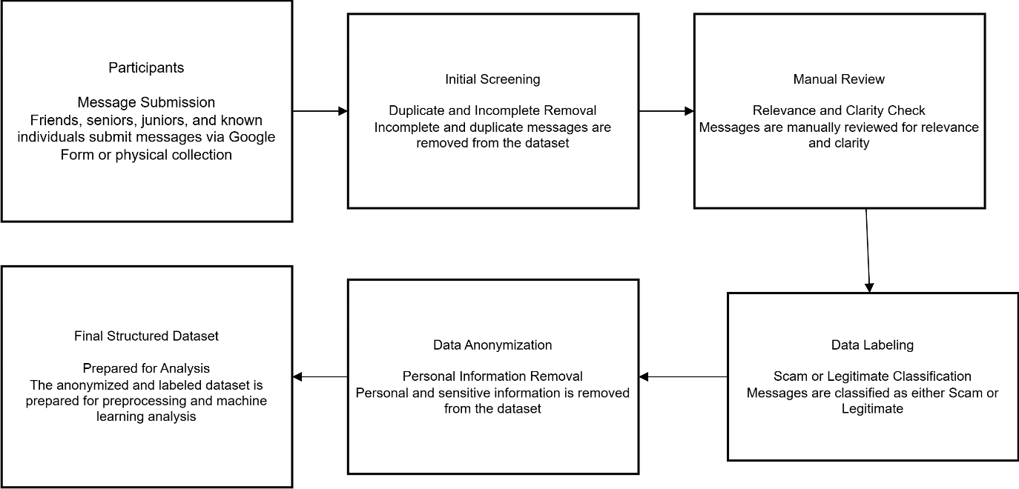

3.5 Data Preprocessing
Data preprocessing is a fundamental step in machine learning that directly influences the performance and reliability of classification models. Since raw textual data often contains noise, inconsistencies, and irrelevant information, it must be transformed into a structured format before being used for analysis. In this study, several preprocessing techniques were applied to enhance data quality and ensure that the dataset was suitable for effective feature extraction and model training.
The preprocessing process began with text cleaning, where unnecessary elements such as special characters, punctuation marks, numerical values, and extra whitespace were removed from the messages. This step helped eliminate noise that could negatively impact model learning. Additionally, all text was converted into lowercase to maintain uniformity and prevent the model from treating identical words with different letter cases as separate features.
Next, tokenization was performed to break each message into smaller units, typically individual words or tokens. Tokenization allows machine learning algorithms to analyze textual components more effectively by identifying patterns within the message structure.
Another important step involved the removal of stop words, which are commonly used words that carry minimal semantic value, such as “the,” “is,” and “and.” Eliminating these words reduces data dimensionality and helps the model focus on meaningful terms that contribute to classification. Since the dataset includes multilingual communication patterns, appropriate stop word filtering was applied to improve textual clarity.
Following stop word removal, duplicate messages were identified and eliminated to prevent model bias. Duplicate data can lead to overfitting, where the model memorizes repeated samples rather than learning generalized patterns. Ensuring dataset uniqueness therefore supports better predictive performance.
Finally, the processed text was reviewed to confirm consistency and readability before proceeding to feature extraction. Through these systematic preprocessing steps, raw messages were transformed into a clean and structured dataset suitable for machine learning analysis. This process plays a critical role in improving classification accuracy and strengthening the overall effectiveness of the proposed financial scam detection system.
Figure 3.2 Text Data Preprocessing Workflow

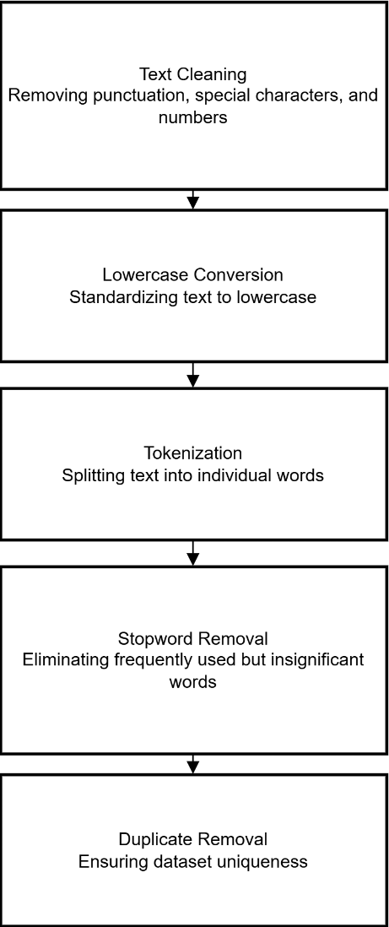

3.6 Feature Extraction
Feature extraction is a crucial stage in text-based machine learning, as algorithms cannot interpret raw textual data directly. Therefore, messages must be transformed into numerical representations that capture meaningful linguistic patterns. In this research, the Term Frequency–Inverse Document Frequency (TF-IDF) technique was employed to convert preprocessed text into structured feature vectors suitable for classification.
TF-IDF is widely recognized as an effective method for text representation because it evaluates the importance of words within a document relative to the entire dataset. The technique consists of two primary components: Term Frequency (TF) and Inverse Document Frequency (IDF). Term Frequency measures how often a word appears in a message, while Inverse Document Frequency reduces the weight of commonly occurring words across multiple messages. By combining these two measures, TF-IDF assigns higher importance to words that are distinctive and potentially more informative for classification.
The application of TF-IDF enables the model to focus on keywords that frequently appear in fraudulent messages, such as terms associated with urgency, financial requests, or promotional claims, while minimizing the influence of commonly used but less informative words. This improves the model’s ability to differentiate between scam and legitimate communication.
Additionally, TF-IDF helps address the high dimensionality typically associated with textual data by generating a sparse matrix representation. Such structured representation enhances computational efficiency and supports effective learning by machine learning algorithms. The extracted features were subsequently used as input for multiple classification models, allowing them to identify patterns and relationships within the dataset.
Overall, the use of TF-IDF contributes significantly to improving classification performance by providing a balanced representation of textual importance. Its simplicity, efficiency, and proven effectiveness in text classification tasks make it a suitable choice for developing the proposed financial scam detection framework.
Figure 3.3 TF-IDF Feature Extraction Process
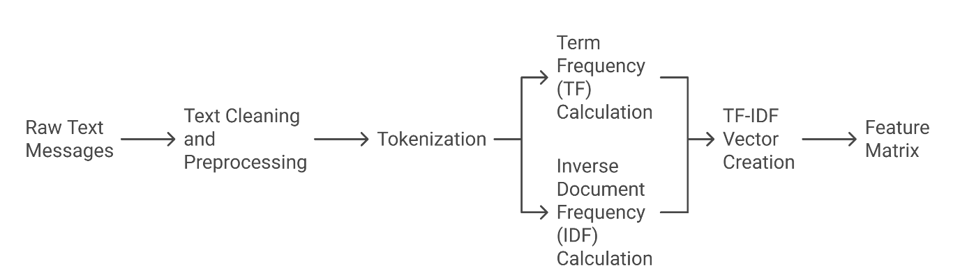

3.7 Model Development
Model development is a crucial phase of this research, focusing on constructing an intelligent classification system capable of distinguishing financial scam messages from legitimate communication. After completing data preprocessing and feature extraction, multiple supervised machine learning algorithms were implemented to learn patterns from the dataset and perform accurate message classification.
Instead of relying on a single algorithm, this study adopts a comparative modeling approach to evaluate the effectiveness of different classifiers. Utilizing multiple models enhances experimental reliability and allows for the identification of the most suitable technique based on predictive performance, generalization capability, and computational efficiency.
Four widely used machine learning algorithms were selected for this research: Support Vector Machine (SVM), Logistic Regression, Random Forest, and K-Nearest Neighbors (KNN). These models were chosen due to their proven effectiveness in text classification tasks and their ability to operate efficiently within high-dimensional feature spaces generated through TF-IDF representation.
The Support Vector Machine (SVM) was implemented for its strong capability in handling binary classification problems. By constructing an optimal hyperplane that maximizes the margin between classes, SVM effectively separates scam messages from legitimate ones. Its robustness in high-dimensional environments makes it particularly suitable for textual data analysis.
Logistic Regression was employed as a baseline classifier due to its simplicity, interpretability, and computational efficiency. Despite being a relatively lightweight algorithm, it performs reliably in text classification scenarios and produces probability-based outputs that support clear decision boundaries.
The Random Forest algorithm was incorporated into leverage ensemble learning principles. This method constructs multiple decision trees during training and aggregates their predictions to produce a final output. Such an approach reduces the likelihood of overfitting while improving prediction stability. Additionally, Random Forest can capture complex and nonlinear relationships within textual features, making it valuable for detecting diverse scam patterns.
To further strengthen the comparative analysis, the K-Nearest Neighbors (KNN) algorithm was implemented as a distance-based classification technique. KNN categorizes messages by analyzing their proximity to neighboring data points within the feature space and assigning labels based on majority voting. Its simplicity and effectiveness in similarity-based pattern recognition make it a useful addition to the modeling framework. Although KNN can be computationally intensive during prediction, it often performs well when meaningful feature representations are used.
Prior to model training, the dataset was divided into training and testing subsets to ensure unbiased evaluation. Each algorithm was trained using the training data and subsequently tested on unseen samples to measure its generalization capability. Appropriate parameter configurations were applied to maintain a balance between predictive performance and computational cost.
The models were then systematically compared using standard evaluation metrics to determine the most effective approach for financial scam detection. This multi-model strategy strengthens the methodological framework by promoting rigorous experimentation and reducing dependency on a single classifier.
Overall, the implementation of diverse machine learning algorithms enhances the robustness and credibility of the proposed detection system. By enabling structured comparison and performance validation, the model development process ensures that the final framework is reliable, efficient, and suitable for real-world digital communication environments.
Accuracy
$$Accuracy=\frac{TP+TN}{TP+TN+FP+FN}$$
Where:
TP = True Positives
TN = True Negatives
FP = False Positives
FN = False Negatives
Precision
$$Precision=\frac{TP}{TP+FP}$$
Measures on how many predicted scam messages were actually fraudulent.

Recall
$$Recall=\frac{TP}{TP+FN}$$
Indicates the model’s ability to correctly identify scam messages.

F1-Score
$$F1=2×\frac{Precision×Recall}{Precision+Recall}$$
Provides a balanced measure between precision and recall.

Table 3.2 Machine Learning Models Used in This Study
Model | Category | Primary Strength
Support Vector Machine (SVM) | Supervised | Effective in high-dimensional text classification
Logistic Regression | Supervised | Fast, interpretable, and computationally efficient
Random Forest | Ensemble | Reduces overfitting and improves prediction stability
K-Nearest Neighbors (KNN) | Distance-Based | Effective for similarity-driven classification

Figure 3.4 – Machine Learning Model Development Process
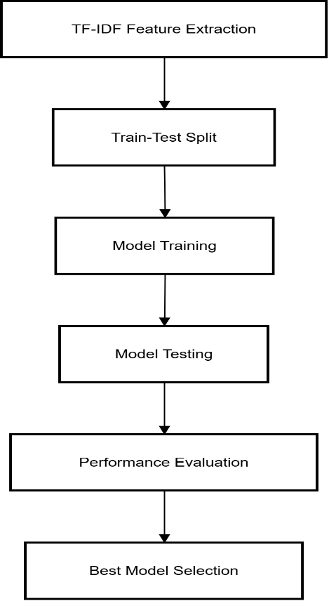
3.8 Model Evaluation
Model evaluation is an essential stage in machine learning that determines how effectively a trained model performs on unseen data. In this research, the developed classification models were systematically evaluated to measure their ability to accurately distinguish financial scam messages from legitimate communication. Proper evaluation ensures the reliability, robustness, and generalization capability of the proposed detection system.
After training the selected machine learning models—Support Vector Machine (SVM), Logistic Regression, Random Forest, and K-Nearest Neighbors (KNN)—their performance was assessed using the testing dataset. Evaluating models on previously unseen data helps prevent overfitting and provides a realistic estimate of how the system would perform in real-world scenarios.
To achieve comprehensive assessment, multiple evaluation metrics were employed rather than relying solely on accuracy. While accuracy measures overall correctness, it may not fully reflect model effectiveness in classification problems where different types of prediction errors carry varying levels of importance. Therefore, this study incorporates additional metrics including precision, recall, and F1-score.
Accuracy represents the proportion of correctly predicted messages relative to the total number of predictions. It provides a general indication of model performance but does not differentiate between error types.
Precision measures the proportion of messages predicted as scams that are actually fraudulent. High precision indicates that the model produces fewer false alarms, which is important for maintaining user trust in automated detection systems.
Recall, also known as sensitivity, evaluates the model’s ability to correctly identify actual scam messages. This metric is particularly important in fraud detection because failing to detect a scam can lead to significant financial consequences.
The F1-score combines precision and recall into a single metric by calculating their harmonic meaning. It provides a balanced evaluation when both false positives and false negatives must be considered.
In addition to these statistical measures, a confusion matrix was utilized to visualize the classification outcomes of the models. The confusion matrix presents the distribution of true positives, true negatives, false positives, and false negatives, enabling a deeper understanding of prediction behavior and potential model weaknesses.
Furthermore, the Receiver Operating Characteristic (ROC) curve was considered to analyze the trade-off between the true positive rate and false positive rate across different threshold values. A model with a larger Area Under the Curve (AUC) demonstrates stronger discriminative capability in separating scam messages from legitimate ones.
By applying multiple evaluation metrics and visualization techniques, this research ensures a rigorous assessment of model performance. Such a structured evaluation approach supports the selection of the most effective algorithm and strengthens the credibility of the proposed financial scam detection framework.
Table 3.3 Evaluation Metrics Used in This Study
Metric | Purpose
Accuracy | Measures overall correctness of predictions
Precision | Evaluates how many predicted scams are fraudulent
Recall | Measures the ability to detect actual scam messages
F1-score | Provides a balance between precision and recall

3.9 Implementation Environment
The implementation environment defines the hardware and software configurations used to develop, train, and evaluate the proposed machine learning models. Establishing a well-structured environment is essential for ensuring experimental consistency, computational efficiency, and research reproducibility.
All experiments in this study were conducted using the Python programming language due to its extensive support for machine learning and data analysis. The models were developed within the Jupyter Notebook environment, which provides an interactive platform for data preprocessing, feature extraction, model training, and performance evaluation.
Several Python libraries were utilized to support different stages of the research. The Scikit-learn library was primarily used for implementing machine learning algorithms, including Support Vector Machine (SVM), Logistic Regression, Random Forest, and K-Nearest Neighbors (KNN). Pandas was employed for data manipulation and dataset organization, while NumPy facilitated efficient numerical computations. Additionally, Matplotlib and Seaborn were used to generate visualizations that aided in performance analysis.
The experiments were executed on a standard computing system equipped with sufficient processing capability to handle text-based machine learning tasks. Since the selected algorithms are computationally efficient, no specialized hardware such as Graphics Processing Units (GPUs) was required.
By utilizing a stable and widely adopted implementation environment, this research ensures methodological transparency and enables future researchers to replicate the experimental setup with minimal difficulty.
Table 3.4 Implementation Tools and Technologies
Component | Technology Used
Programming Language | Python
Development Environment | Jupiter Notebook
Machine Learning Library | Scikit-learn
Data Processing | Pandas, NumPy
Visualization Tools | Matplotlib, Seaborn

Figure 3.5 Overall Research Workflow of the Proposed Financial Scam Detection System

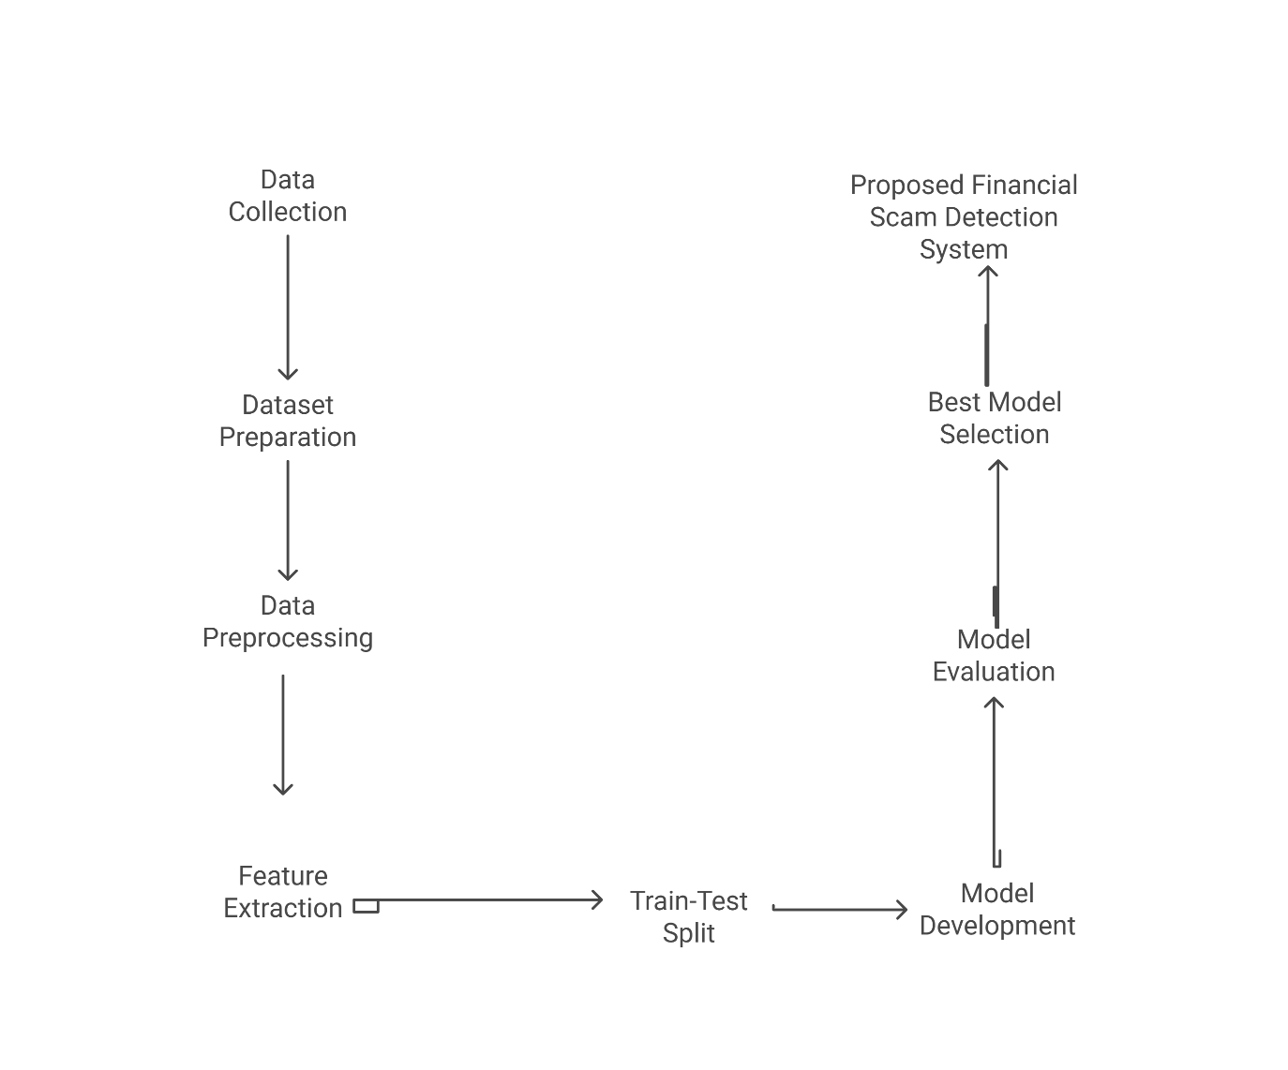
3.10 Chapter Summary
This chapter presented the research methodology adopted for developing the proposed financial scam detection system. It described the overall research approach, dataset construction, and data collection procedures, followed by preprocessing and feature extraction techniques used to transform textual data into structured representations. Multiple machine learning models were implemented and evaluated using standard performance metrics to ensure reliable classification. Additionally, the implementation environment was outlined to support experimental transparency and reproducibility. The methodological workflow provides a strong foundation for analyzing model performance, which is discussed in the following chapter.

Chapter 4 – Results and Discussion
This chapter presents the experimental results obtained from the machine learning models developed for financial scam message detection. The performance of Support Vector Machine (SVM), Logistic Regression, Random Forest, and K-Nearest Neighbors (KNN) was evaluated using standard classification metrics. The results are analyzed to identify the most effective model and to understand the strengths and limitations of each approach. Visualizations such as performance tables, confusion matrices, and ROC curves are used to provide a comprehensive interpretation of the findings.
4.1 Dataset Analysis
Before training the machine learning models, an exploratory analysis was conducted to better understand the structural characteristics of the dataset. Examining textual properties such as message length helps identify patterns that may influence classification performance. One important attribute considered in this study is the average number of words present in scam and legitimate messages.

Figure 4.1 Class Distribution of Scam and Ham Messages
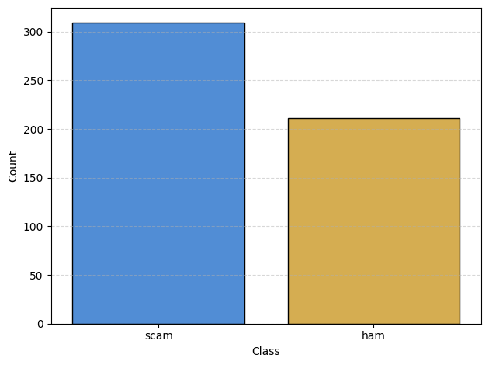
As illustrated in Figure 4.1, the dataset contains a higher number of scam messages compared to legitimate messages. This distribution indicates a moderate class imbalance within the dataset. Such imbalance can influence the learning behavior of machine learning algorithms, as models may become biased toward the majority class during training. Therefore, careful model evaluation using multiple performance metrics, including precision, recall, and F1-score, is necessary to ensure reliable classification outcomes. Despite the variation in class frequency, the dataset provides sufficient representation of both message types, enabling the development of an effective financial scam detection system.

Table 4.1 Average Word Count in Scam and Ham Messages
Message Type | Average Number of Words
Scam | 11.09
Ham | 9.93

Table presents the comparison of average word counts between scam and legitimate messages. The results indicate that scam messages tend to be slightly longer, containing an average of 11.09 words, whereas legitimate messages contain approximately 9.93 words.
This variation suggests that fraudulent messages often include additional persuasive elements such as urgency, financial incentives, or requests for sensitive information. In contrast, legitimate messages are generally shorter and more straightforward in nature.
Understanding these textual differences is valuable, as message length can serve as an informative feature that supports machine learning models in distinguishing between fraudulent and non-fraudulent communication. Such insights contribute to improving the overall effectiveness of the scam detection system.
Table 4.2 Average Message Length in Scam and Ham SMS
Message Type | Average Character Length
Scam | 70.10
Ham | 59.88

As presented in Table, scam messages are noticeably longer in terms of character length compared to legitimate messages. The higher average length indicates that fraudulent messages often contain expanded content such as promotional statements, urgent warnings, or requests for sensitive financial information.
The combined analysis of word count and message length highlights a consistent structural difference between scam and legitimate communication. These variations provide useful signals for machine learning algorithms, enabling them to better recognize patterns associated with fraudulent messaging.
Understanding such textual characteristics strengthens the foundation of the classification process and contributes to improving the overall effectiveness of the proposed financial scam detection system.
Table 4.3 Average Number of Sentences in Scam and Ham Messages
Message Type | Average Number of Sentences
Scam | 1.56
Ham | 1.27
Table illustrates the comparison of the average number of sentences between scam and legitimate messages. The findings reveal that scam messages typically contain more sentences than legitimate messages, indicating a tendency toward longer and more descriptive communication.
Fraudulent messages often incorporate multiple statements to create urgency, provide instructions, or persuade recipients to take immediate action. In contrast, legitimate messages are generally concise and focus on delivering straightforward information.
This structural difference further supports the observation that scam messages exhibit greater textual complexity. Such characteristics can assist machine learning models in identifying hidden patterns within fraudulent communication, thereby enhancing classification accuracy.
Overall, the exploratory analysis demonstrates consistent differences in word count, message length, and sentence structure between scam and legitimate messages. Scam messages tend to be longer, contain more words, and include multiple sentences, reflecting their persuasive nature. These textual variations provide meaningful indicators that support feature extraction and improve the effectiveness of machine learning-based financial scam detection.
To further understand the relationships among the extracted textual features, a correlation analysis was conducted. Examining the degree of association between variables such as message length, word count, and sentence count helps identify patterns that may influence model learning and feature importance.

Figure 4.2 Correlation Matrix of Textual Features
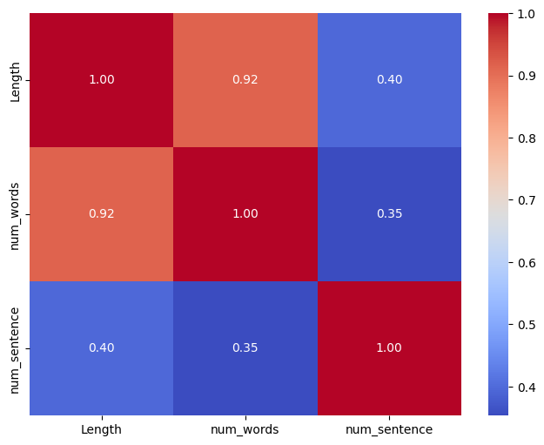
As illustrated in Figure, a strong positive correlation (0.92) is observed between message length and word count, indicating that longer messages generally contain more words. This relationship is expected, as both features measure the overall size of a message. In contrast, sentence count shows a weaker correlation with both length (0.40) and word count (0.35), suggesting that the number of sentences varies independently from message size. These findings indicate that while some features capture similar structural characteristics, others provide unique information that may enhance classification performance. Understanding these relationships supports effective feature selection and contributes to improving the reliability of the machine learning models.
Figure 4.3 Most Frequent Words in Scam Messages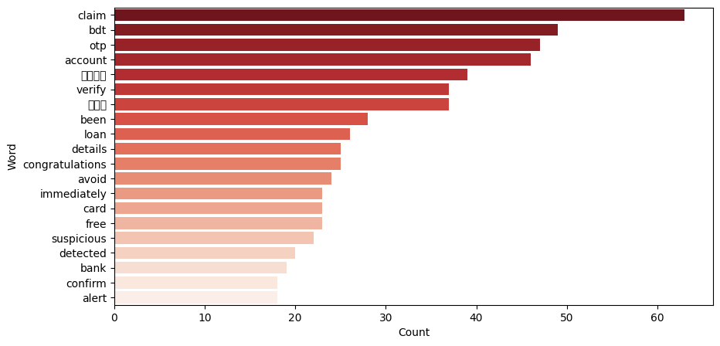
As illustrated in Figure, scam messages frequently contain words related to financial transactions, verification requests, rewards, and urgent actions. Terms such as “claim,” “OTP,” “account,” and “loan” reflect common strategies used by fraudsters to create a sense of urgency and manipulate recipients into sharing sensitive information. The presence of such trigger words highlights distinctive linguistic patterns that can significantly enhance the effectiveness of machine learning-based scam detection.

Figure 4.4 Most Frequent Words in Ham Messages
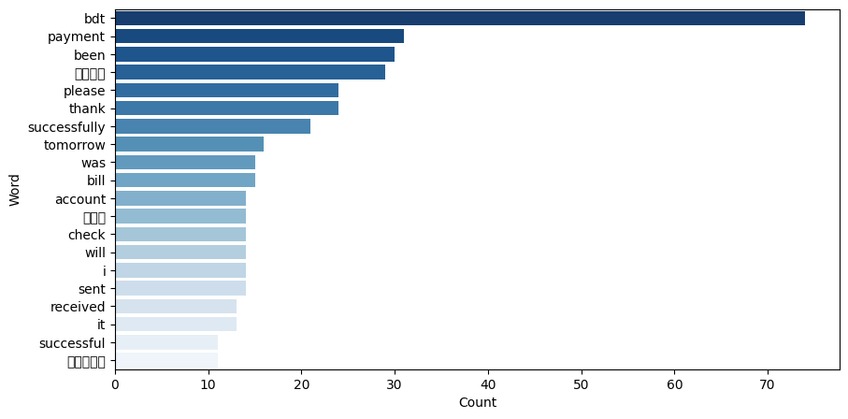
Figure shows that legitimate messages predominantly include neutral and context-specific vocabulary associated with routine communication. Words such as “payment,” “please,” “thanks,” and “sent” indicate informational or transactional interactions rather than manipulative intent. Unlike scam messages, legitimate texts typically avoid urgency-driven language, demonstrating a clear contrast in communication style that supports accurate classification.
Overall, the lexical analysis reveals clear vocabulary distinctions between scam and legitimate messages. While fraudulent texts often rely on persuasive and action-oriented language, legitimate messages tend to maintain a neutral tone. These linguistic differences further strengthen the dataset’s suitability for machine learning applications and contribute to improving the reliability of the proposed financial scam detection system.

4.2 Experimental Setup
To ensure a systematic experimental procedure, a structured machine learning workflow was designed for financial scam message detection. The workflow illustrates the sequential steps followed in this study, beginning with dataset preparation and continuing through preprocessing, feature extraction, model training, and performance evaluation. This structured approach helps maintain consistency in experimentation and improves the reliability of the obtained results. The overall experimental pipeline is presented in Figure.
Figure 4.5 Machine Learning Workflow for Financial Scam Detection
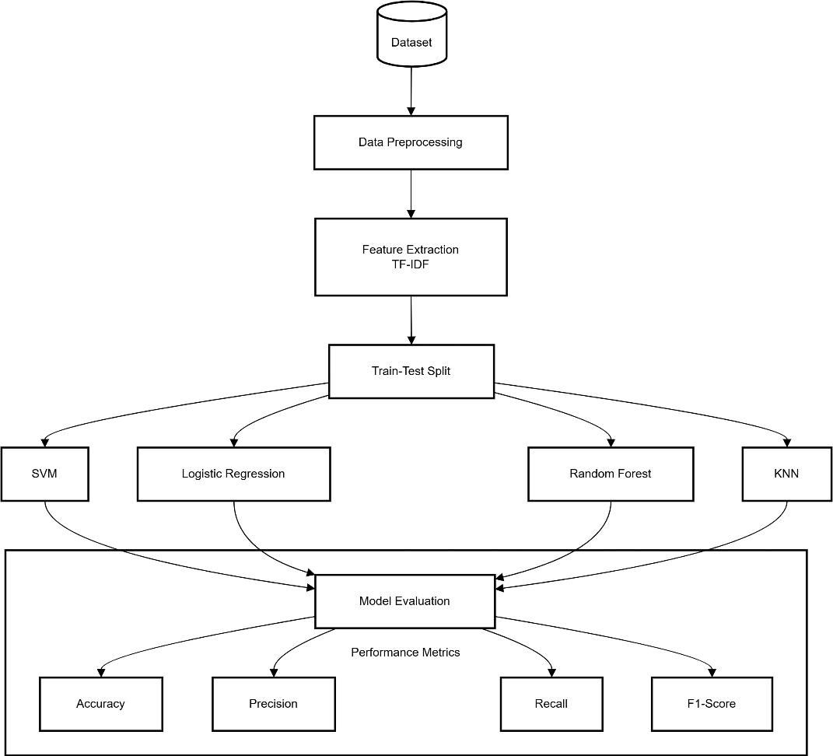
As shown in Figure, the process begins with the dataset, which undergoes data preprocessing to remove noise and enhance text quality. The cleaned data is then transformed into numerical representations using the TF-IDF feature extraction technique. Following this step, the dataset is divided into training and testing subsets to enable unbiased model evaluation.
Multiple supervised machine learning algorithms—Support Vector Machine (SVM), Logistic Regression, Random Forest, and K-Nearest Neighbors (KNN)—are trained using the prepared data. The trained models are subsequently evaluated using standard performance metrics, including accuracy, precision, recall, and F1-score, to determine their effectiveness in detecting financial scam messages.
This workflow ensures a comprehensive experimental design, allowing for a fair comparison of different classifiers while supporting the identification of the most effective model for the proposed detection system.
4.3 Performance Comparison of Machine Learning Models
The performance of the developed machine learning models was systematically evaluated to determine their effectiveness in detecting financial scam messages. Four supervised classification algorithms—Support Vector Machine (SVM), Logistic Regression, Random Forest, and K-Nearest Neighbors (KNN)—were assessed using standard evaluation metrics, including accuracy, precision, recall, and F1-score.
Evaluating multiple metrics provides a comprehensive understanding of model behavior, as relying solely on accuracy may not fully capture classification performance, particularly in fraud detection scenarios where false predictions can have serious consequences. The comparative results of the trained models are presented below Table.

Table 4.4 Performance Comparison of Machine Learning Models
Model | Accuracy (%) | Precision (%) | Recall (%) | F1-score (%)
Support Vector Machine (SVM) | 96.2 | 96.8 | 96.8 | 96.8
Logistic Regression | 92.3 | 93.5 | 93.5 | 93.5
Random Forest | 90.4 | 90.6 | 93.5 | 92.1
K-Nearest Neighbors (KNN) | 94.2 | 93.8 | 96.8 | 95.2

Table 4.1 presents the comparative performance of the evaluated machine learning models for financial scam message detection. The results indicate noticeable variations in classification capability across the four algorithms.
Among the evaluated models, Support Vector Machine (SVM) achieved the highest accuracy of 96.2%, demonstrating its strong ability to distinguish between scam and legitimate messages. The model also produced the highest precision, recall, and F1-score of 96.8%, indicating balanced performance with minimal false predictions. This effectiveness can be attributed to SVM’s capability to operate efficiently in high-dimensional feature spaces, making it particularly suitable for text classification tasks.
The K-Nearest Neighbors (KNN) model delivered the second-best performance with an accuracy of 94.2% and a high F1-score of 95.2%. Its strong recall suggests that the model is highly effective in identifying scam messages, thereby reducing the likelihood of undetected fraudulent communication.
Logistic Regression demonstrated stable and reliable performance, achieving an accuracy of 92.3% along with balanced precision and recall values. These results highlight its effectiveness as a baseline classifier while maintaining computational simplicity.
In contrast, the Random Forest model recorded the lowest accuracy at 90.4%. Although ensemble methods often perform well in classification problems, the comparatively lower result may indicate that the textual features extracted through TF-IDF are better separated using margin-based techniques such as SVM.
Overall, the comparative analysis reveals that margin-based and distance-based classifiers outperform ensemble learning for this particular dataset. Based on these findings, Support Vector Machine (SVM) is identified as the best-performing model and is therefore selected for further evaluation and analysis in subsequent sections.
4.4 Confusion Matrix Analysis
To further evaluate the classification effectiveness of the proposed financial scam detection system, a confusion matrix was generated for the best-performing model, Support Vector Machine (SVM). The confusion matrix provides a detailed breakdown of prediction outcomes by illustrating the number of correctly and incorrectly classified messages.
It categorizes predictions into four groups: true positives, true negatives, false positives, and false negatives. True positives represent scam messages correctly identified as fraudulent, while true negatives indicate legitimate messages accurately classified as non-scam. Conversely, false positives occur when legitimate messages are incorrectly flagged as scams, and false negatives represent fraudulent messages that the model failed to detect.
The confusion matrix of the SVM model is presented in Figure .
Figure 4.6 Confusion Matrix of the Support Vector Machine (SVM) Model

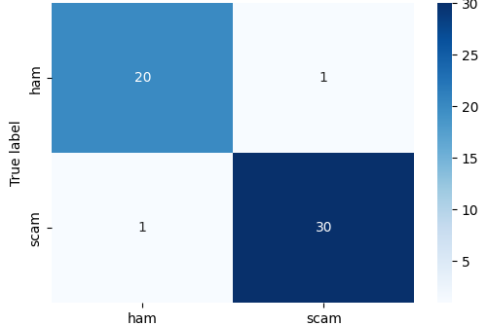
As illustrated in Figure, the Support Vector Machine (SVM) model demonstrates excellent classification performance in detecting financial scam messages. The confusion matrix shows that the model correctly identified 30 scam messages and 20 legitimate messages, reflecting its strong predictive capability.
Only one legitimate message was incorrectly classified as a scam (false positive), while one scam message was misclassified as legitimate (false negative). The low number of misclassifications indicates that the model maintains a high level of accuracy while effectively distinguishing between fraudulent and non-fraudulent communication.
Minimizing false positives is essential to prevent unnecessary alerts that could reduce user confidence in the detection system. Similarly, the very small number of false negatives highlights the model’s effectiveness in identifying potentially harmful messages, thereby lowering the risk of undetected financial scams.
Overall, the confusion matrix validates the robustness and reliability of the SVM classifier, supporting its selection as the best-performing model for financial scam detection.
These results demonstrate the practical applicability of the proposed model in real-world messaging environments where accurate and timely detection of fraudulent messages is critical.
4.5 ROC Curve Analysis
To further evaluate the classification performance of the proposed financial scam detection system, the Receiver Operating Characteristic (ROC) curve was analyzed for the best-performing model, Support Vector Machine (SVM). The ROC curve illustrates the trade-off between the True Positive Rate (TPR) and the False Positive Rate (FPR) across different classification thresholds, providing a comprehensive measure of the model’s discriminative ability. A model that produces a curve closer to the upper-left corner demonstrates stronger classification capability, indicating higher detection accuracy with fewer false alarms. The ROC curve of the SVM model is presented in Figure 4.2.
Figure 4.7 ROC Curve of the Support Vector Machine (SVM) Model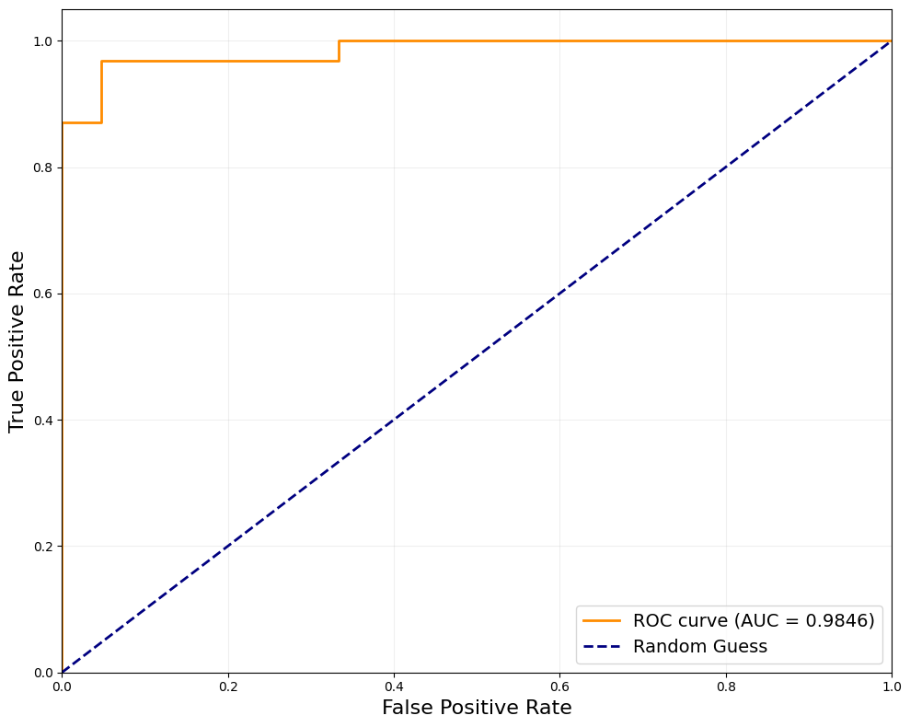
As illustrated in Figure , the ROC curve remains close to the upper-left boundary, indicating excellent separability between scam and legitimate messages. The model achieved an Area Under the Curve (AUC) value of 0.98, which reflects outstanding classification performance. A high AUC value signifies that the model is highly capable of distinguishing fraudulent messages from normal communication. This level of performance is particularly important in financial scam detection, where accurate identification of malicious messages helps reduce potential financial risks. The strong ROC result further validates the robustness of the Support Vector Machine classifier and confirms its suitability for real-world deployment in automated scam detection systems.
Therefore, the ROC analysis reinforces the effectiveness of the proposed approach and demonstrates its potential to enhance user security by enabling reliable and timely detection of financial scam messages.
4.6 Discussion of Results
The experimental findings demonstrate the effectiveness of machine learning techniques in detecting financial scam messages. Among the evaluated classifiers, the Support Vector Machine (SVM) achieved the highest performance across all evaluation metrics, confirming its strong capability in handling high-dimensional textual data. The superior accuracy and balanced precision-recall values indicate that the model can reliably differentiate between fraudulent and legitimate messages.
One of the primary reasons behind the strong performance of SVM is its margin-based learning mechanism, which enables optimal separation between classes. Since text data transformed through TF-IDF typically results in sparse and high-dimensional feature spaces, SVM is particularly well-suited for such classification tasks.
The K-Nearest Neighbors (KNN) algorithm also produced competitive results, demonstrating high recall and F1-score values. This suggests that the model is effective in identifying scam messages, thereby reducing the likelihood of undetected fraud. However, KNN relies heavily on distance calculations, which can become less efficient in high-dimensional environments.
Logistic Regression delivered stable and consistent performance, highlighting its reliability as a baseline classifier for text classification problems. Its balanced evaluation metrics indicate that linear models remain a practical choice when computational simplicity and interpretability are desired.
In contrast, the Random Forest model showed comparatively lower accuracy than the other algorithms. Although ensemble methods are generally powerful, their performance may be influenced by the nature of textual data, where linear decision boundaries can sometimes provide better class separation than tree-based approaches.
The confusion matrix further confirmed the robustness of the SVM model, revealing only a minimal number of misclassifications. Both false positives and false negatives were extremely low, which is critical in scam detection systems where incorrect predictions can either create unnecessary alerts or allow fraudulent messages to go unnoticed.
Additionally, the ROC analysis produced an AUC score of 0.98, indicating excellent discriminative ability. Such high value suggests that the model maintains a strong balance between sensitivity and specificity, making it highly dependable for automated detection tasks.
Overall, the results highlight that selecting an appropriate classification algorithm plays a crucial role in enhancing detection performance. The strong outcomes achieved by the SVM model demonstrate the effectiveness of the proposed approach and its potential applicability in real-world financial scam detection systems.
4.7 Error Analysis
Although the Support Vector Machine (SVM) model achieved excellent classification performance, a small number of misclassifications were observed. Analyzing these prediction errors is important for understanding the limitations of the model and identifying opportunities for future improvement.
The confusion matrix revealed very few false positives and false negatives, indicating that the classifier performs reliably in most scenarios. However, false positives occurred when legitimate messages were incorrectly flagged as scams. Such errors may arise when normal messages contain promotional language, numerical information, or urgency-related terms that resemble patterns commonly found in fraudulent communication.
False negatives represent scam messages that were mistakenly classified as legitimate. These errors are particularly critical because undetected fraudulent messages may expose users to financial risks. In many cases, such messages may use subtle or less obvious wording, making them harder for the model to distinguish from regular communication.
Another contributing factor to misclassification is the variability in writing styles. Scam messages often evolve to bypass automated detection systems by adopting more natural language patterns. Similarly, short messages with limited contextual information can reduce the effectiveness of feature extraction techniques such as TF-IDF.
Despite these challenges, the extremely low number of classification errors demonstrates the robustness of the proposed model. Future improvements could focus on expanding the dataset, incorporating semantic features, or leveraging advanced language models to further enhance detection accuracy.
Overall, the error analysis confirms that while the model is highly reliable, continuous refinement is essential for developing more resilient financial scam detection systems.

4.7.1 Analysis of False Positives
False positives occur when legitimate messages are incorrectly classified as scams. Such errors may arise when normal messages contain characteristics commonly associated with fraudulent communication, such as promotional wording, numerical content, hyperlinks, or urgent language.
Although false positives do not directly expose users to financial threats, frequent incorrect alerts could reduce user trust in the detection system. Therefore, minimizing these errors is important to ensure a balanced and user-friendly automated filtering experience.
4.7.2 Analysis of False Negatives
False negatives represent fraudulent messages that are mistakenly classified as legitimate. This type of error is particularly critical in financial scam detection because undetected malicious messages may lead to financial loss or compromise sensitive information.
False negatives can occur when scam messages adopt more natural language patterns or avoid commonly used trigger words, making them harder for the model to identify. This highlights the evolving nature of fraudulent communication and the need for continuous model refinement. Reducing false negatives should remain a priority in future improvements, as enhancing detection sensitivity directly contributes to stronger user protection.
4.8 Chapter Summary
This chapter presented the experimental results and analysis of the machine learning models developed for financial scam message detection. An initial dataset analysis highlighted structural differences between scam and legitimate messages in terms of word count, character length, and sentence composition, providing valuable insights for the classification process.
Multiple supervised learning algorithms were evaluated to determine the most effective model for detecting fraudulent communication. Among the tested classifiers, the Support Vector Machine (SVM) demonstrated superior performance across all evaluation metrics, confirming its suitability for high-dimensional text classification tasks.
The confusion matrix and ROC curve further validated the robustness of the selected model, revealing strong predictive capability with minimal misclassification and excellent class separability. Additionally, the discussion of results provided an interpretation of model behavior, while the error analysis offered a critical understanding of the system’s limitations and potential areas for improvement.
Overall, the findings indicate that the proposed approach is both reliable and effective for financial scam detection. The next chapter concludes the study by summarizing the research contributions, outlining key limitations, and presenting directions for future work.

Chapter 5 Conclusion
5.1 Conclusion
This study presented a machine learning-based approach for detecting financial scam messages using textual data. The primary objective was to develop an effective classification system capable of distinguishing fraudulent messages from legitimate communication.
An exploration analysis of the dataset revealed noticeable structural differences between scam and legitimate messages in terms of word count, message length, and sentence composition. These insights supported the feature extraction process and contributed to improving model performance. Multiple supervised learning algorithms were implemented and evaluated, including Support Vector Machine (SVM), Logistic Regression, Random Forest, and K-Nearest Neighbors (KNN). Among these models, the Support Vector Machine demonstrated superior performance across all evaluation metrics, achieving high accuracy along with balanced precision and recall. The confusion matrix and ROC curve further validated the robustness of the selected model, indicating strong discriminative ability with minimal misclassification. The findings confirm that machine learning techniques can effectively enhance automated financial scam detection and support safer digital communication environments. Overall, the proposed system provides a reliable and scalable solution for identifying fraudulent messages and demonstrates the practical potential of machine learning in cybersecurity applications.
5.2 Limitations
Despite achieving strong classification performance, this study has several limitations. First, the dataset size was relatively limited, which may affect the generalizability of the model across larger and more diverse communication environments.
Second, the system relied primarily on textual features extracted through TF-IDF, which may not fully capture deeper semantic meaning or contextual relationships within messages.
Additionally, scam communication continuously evolves, and newly emerging fraud patterns may reduce model effectiveness over time if periodic retraining is not performed.
Addressing these limitations would further enhance the robustness and adaptability of the proposed detection system.
5.3 Future Work
Future research can focus on expanding the dataset to include more diverse message formats and linguistic variations to improve model generalization. Incorporating advanced natural language processing techniques, such as word embeddings or transformer-based models, may further enhance detection accuracy.
Additionally, real-time deployment of the detection system could be explored to enable instant identification of fraudulent messages. Integrating the model into mobile applications or messaging platforms may significantly strengthen user protection against financial scams.
Continuous model updates and adaptive learning strategies should also be considered to address the rapidly evolving nature of cyber fraud.
5.4 Ethical Considerations
Ethical considerations play an important role in the development of automated scam detection systems. This study ensured that all collected messages were handled responsibly and used solely for academic research purposes.
Personal identifiers and sensitive information were excluded to maintain privacy and confidentiality. Furthermore, the proposed system is intended to assist users in identifying potentially harmful messages rather than replacing human judgment.
Developers must ensure that such technologies are implemented transparently and responsibly to prevent misuse, minimize false accusations, and promote trust in automated security solutions.

References

- Almeida, T. A., Gómez Hidalgo, J. M., & Yamakami, A. (2011). Contributions to the study of SMS spam filtering: New collection and results. Proceedings of the 11th ACM Symposium on Document Engineering, 259–262. https://doi.org/10.1145/2034691.2034742
- Uysal, A. K., & Gunal, S. (2014). The impact of preprocessing on text classification. Information Processing & Management, 50(1), 104–112. https://doi.org/10.1016/j.ipm.2013.08.006
- Sethi, K., Kumar, R., & Saini, M. (2020). SMS spam detection using machine learning techniques: A comparative analysis. Procedia Computer Science, 167, 189–196. https://doi.org/10.1016/j.procs.2020.03.196
- Salman, A. G., Heryadi, Y., Abdurahman, E., & Suparta, W. (2022). SMS spam detection using machine learning approach. Procedia Computer Science, 157, 843–850. https://doi.org/10.1016/j.procs.2019.08.215
- Putra, D. W. T., et al. (2023). Comparative analysis of machine learning algorithms for SMS spam detection. International Journal of Advanced Computer Science and Applications, 14(2), 455–462.
- Ali, M. H., Shahriar, H., & Rahman, M. (2022). Financial fraud detection using machine learning: A systematic literature review. IEEE Access, 10, 134742–134770. https://doi.org/10.1109/ACCESS.2022.3228285
- Udayakumar, R., Karthikeyan, T., & Balamurugan, S. (2023). Deep Fraud Net: A deep learning framework for financial fraud detection. Journal of Information Security and Applications, 72, 103390. https://doi.org/10.1016/j.jisa.2023.103390
- Onu, S., Okwuashi, O., & Nwankwo, W. (2023). Detecting fraudulent financial transactions using machine learning algorithms. Expert Systems with Applications, 213, 118983. https://doi.org/10.1016/j.eswa.2022.118983
- Cortes, C., & Vapnik, V. (1995). Support-vector networks. Machine Learning, 20(3), 273–297. https://doi.org/10.1007/BF00994018
- Breiman, L. (2001). Random forests. Machine Learning, 45(1), 5–32. https://doi.org/10.1023/A:1010933404324
- Cover, T., & Hart, P. (1967). Nearest neighbor pattern classification. IEEE Transactions on Information Theory, 13(1), 21–27. https://doi.org/10.1109/TIT.1967.1053964
- Ramos, J. (2003). Using TF-IDF to determine word relevance in document queries. Proceedings of the First Instructional Conference on Machine Learning.
- Aggarwal, C. C., & Zhai, C. (2012). A survey of text classification algorithms. Mining Text Data, 163–222. https://doi.org/10.1007/978-1-4614-3223-4_6
- Chandrasekaran, M., Narayanan, K., & Upadhyaya, S. (2006). Phishing email detection based on structural properties. NY State Cyber Security Conference.
- Sahingoz, O. K., Buber, E., Demir, O., & Diri, B. (2019). Machine learning based phishing detection from URLs. Expert Systems with Applications, 117, 345–357. https://doi.org/10.1016/j.eswa.2018.09.029
- Bahnsen, A. C., Aouada, D., & Ottersten, B. (2016). Example-dependent cost-sensitive logistic regression for credit card fraud detection. 2014 13th International Conference on Machine Learning and Applications, 333–338.
- Zheng, L., & Liu, G. (2018). Spam detection using deep learning networks. Journal of Intelligent & Fuzzy Systems, 35(5), 5553–5563.
- Kim, Y. (2014). Convolutional neural networks for sentence classification. Proceedings of the 2014 Conference on EMNLP, 1746–1751.

